CST8502 - Lab 5
Python Exercise
Student Name: Peng Wang
Student Number: 041107730

For every step, include screenshot of the code AND the corresponding results (screenshot from colab/jupyter notebook) in this document. Also, in your words, explain your code and results. If there is no explanation, no marks will be given. No need to write long paragraphs, but one or 2 lines per step. When you copy code, make sure to copy and paste the code relevant to that step. Don’t merge multiple steps.

- Random seed
Fixed random seeds(2025) are initialized for both Python’s random module and NumPy’s random number generator to ensure reproducible results across multiple runs.
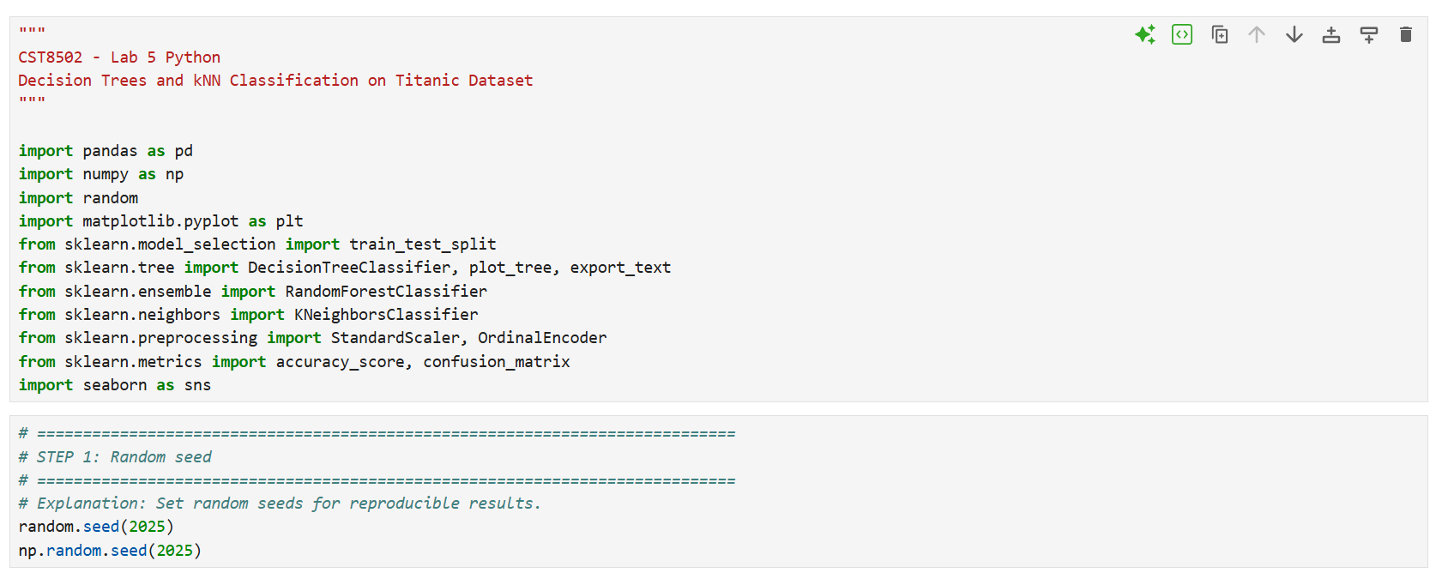

- Load data and print stats
The Titantic dataset is imported from CSV and basic information is displayed: total instance count, attribute count, and a preview of the first 5 rows.
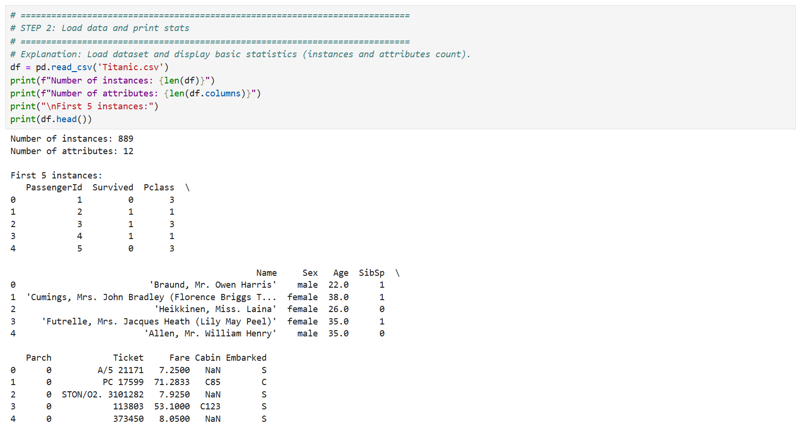
- Quality check
Missing values are identified and reported. Irrelevant columns (PassengerId, Name, Ticket, Cabin) are removed. Relevant features retained: Pclass, Sex, Age, SibSp, Parch, Fare, Embarked, and Survived.
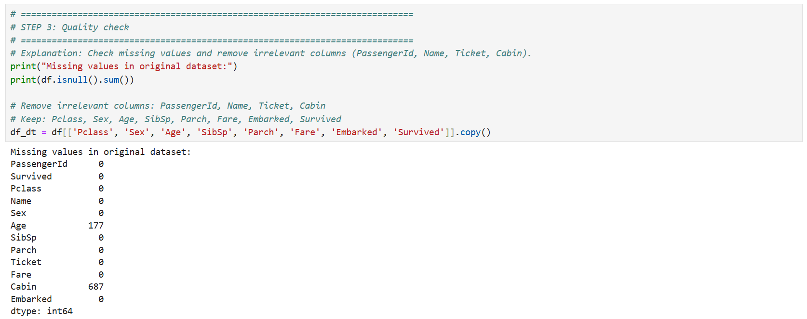
- Creation of new columns
Numerical data is discretized into categories. AgeCroup: NK(missing), Baby(<3),Child(3-12),Teen(13-19),Adult(20-60),Senior(60+). SibSp and Parch are summed into Relatives, then categorized: None(0), One(1), Few(2-4), Many(5+). Fare groups: Free(0), Low(<50), average(<100), high(>=100).
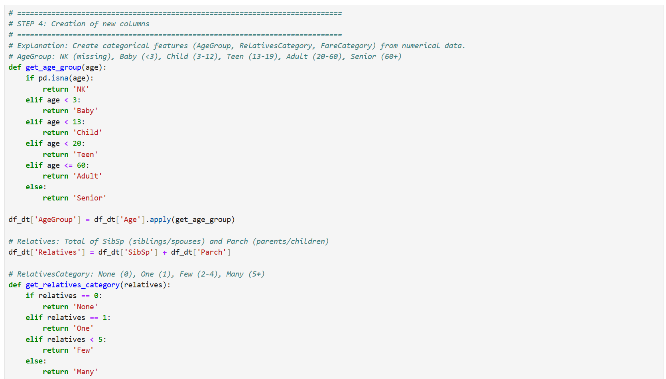
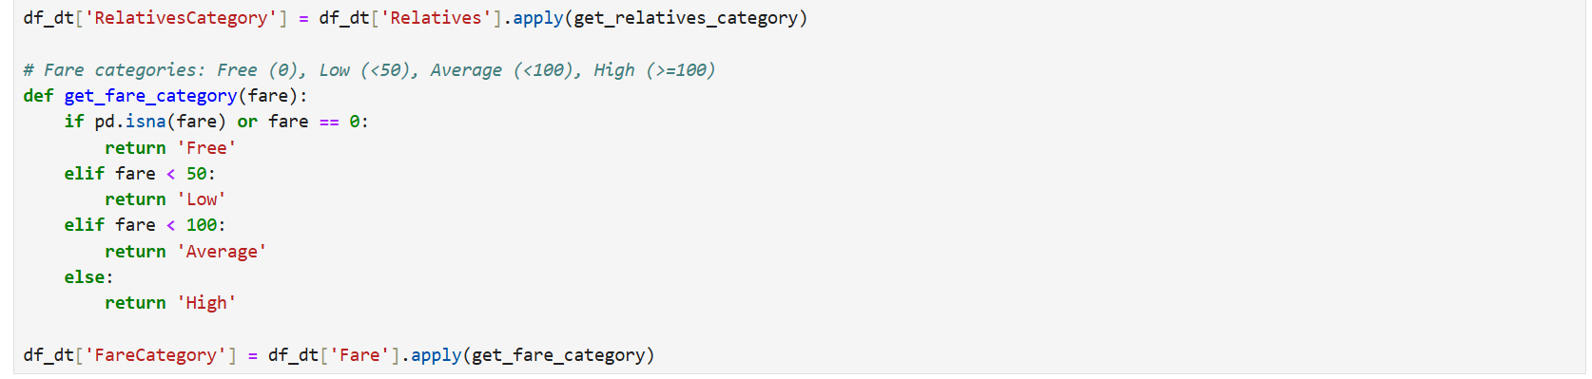
- First 5 rows
The final feature set is displayed: Pclass, Sex, AgeGroup, RelativesCategory, FareCategory, Embarked, and Survived.
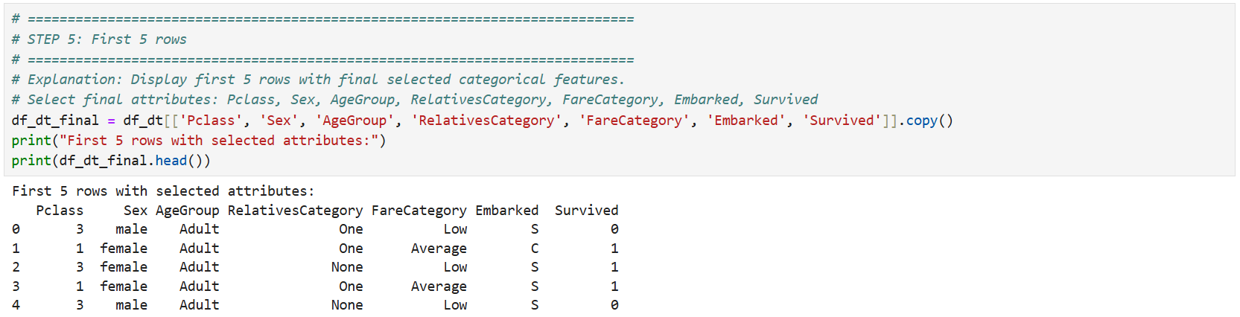
- One-hot encoding
Categorical variables are converted into binary columns using one-hot encoding. Features and target are separated. Each category becomes its own binary column(0/1)
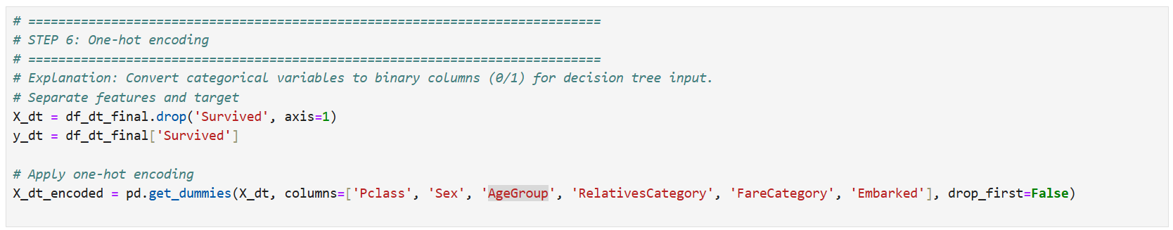
- Train-Test Split
The dataset is split 80% training and 20% testing with stratification to preserve label distribution in both sets.
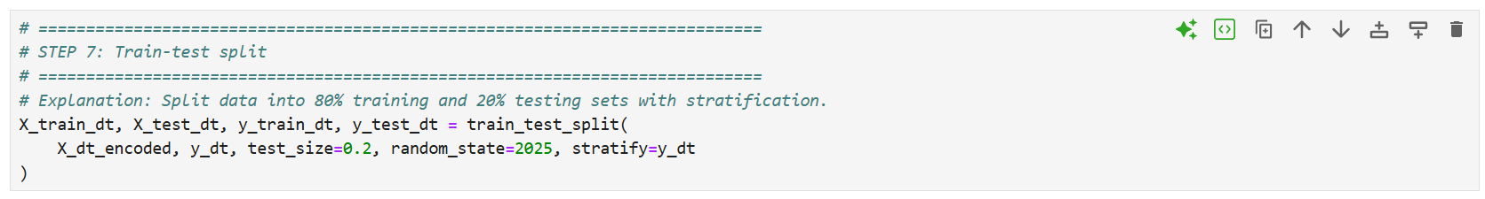

- Model fitting
A DecisionTreeClassifier is trained on the training set. The tree structure is built by recursive splits on feature conditions.
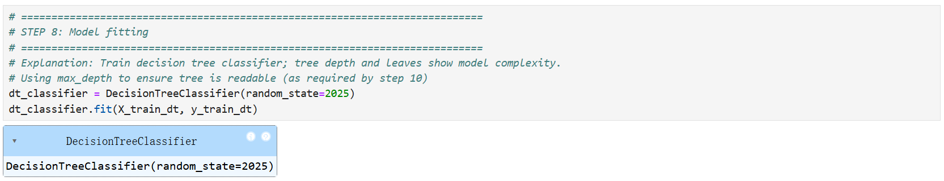
- Prediction, accuracy, confusion matrix
Predictions are made on the test set. Accuracy is the proportion of correct predictions. A confusion matrix summarizes TP, FP, TN, and FN, visualized with a heatmap.
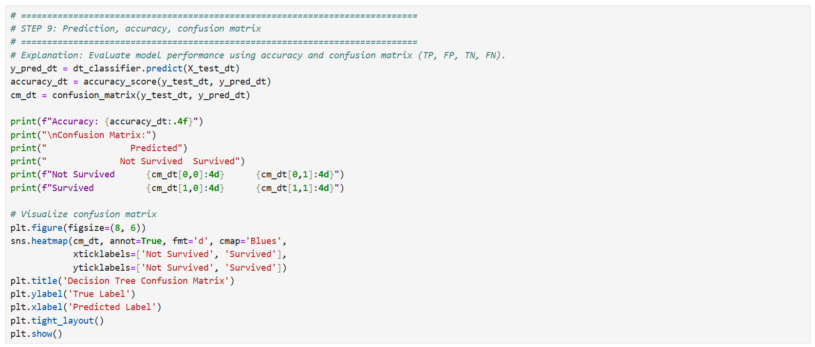
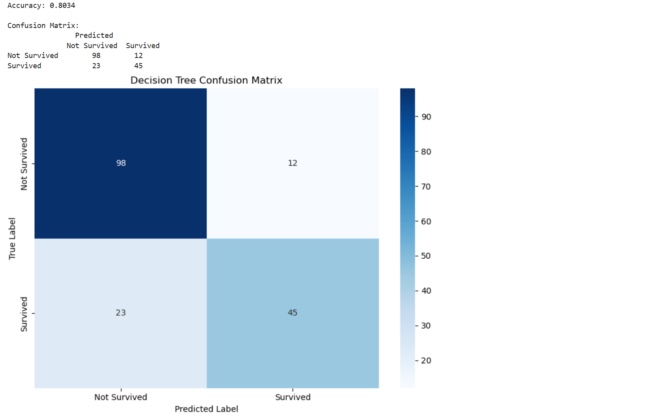
- Tree
The decision tree is visualized. One-hot encoded feature names are mapped to readable lables (e.g., "Sex_male <= 0.5" → "Sex = female") and the tree is displayed with a max depth of 3.
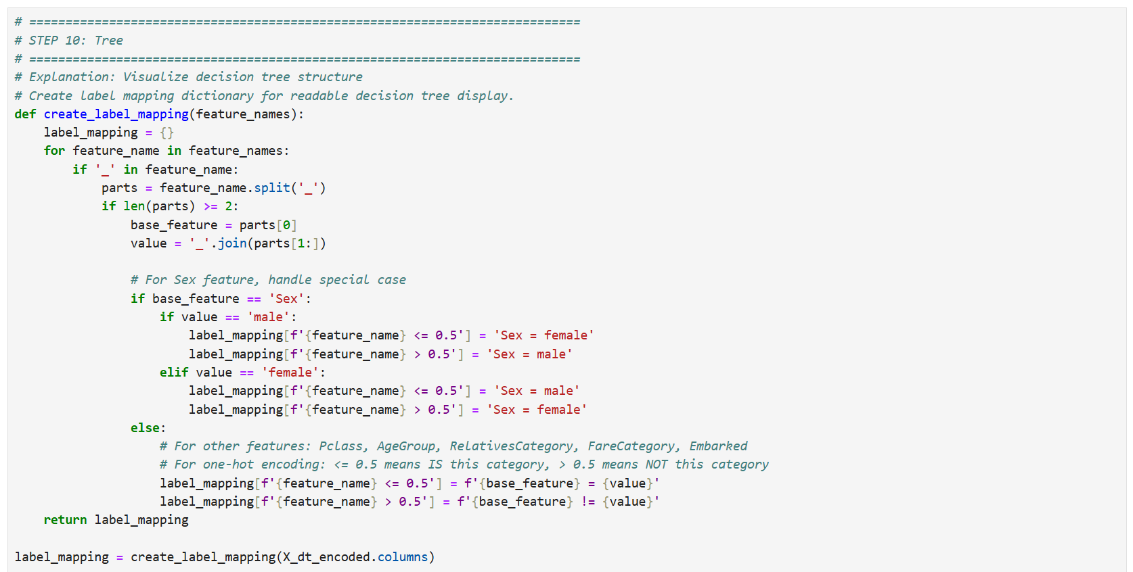
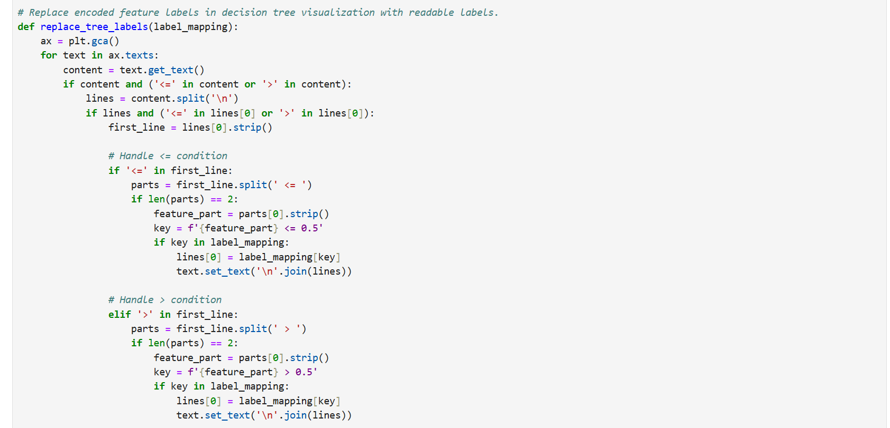
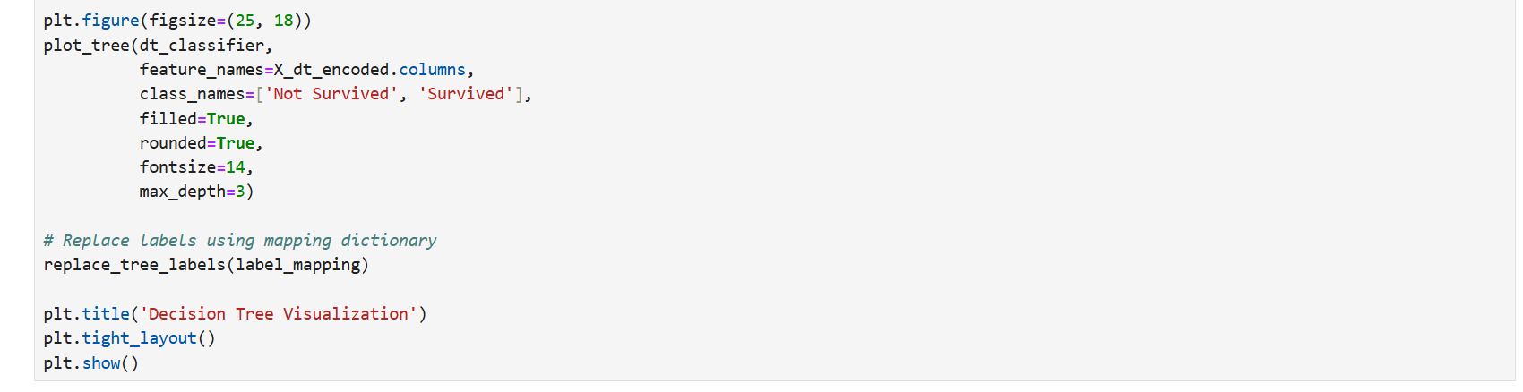
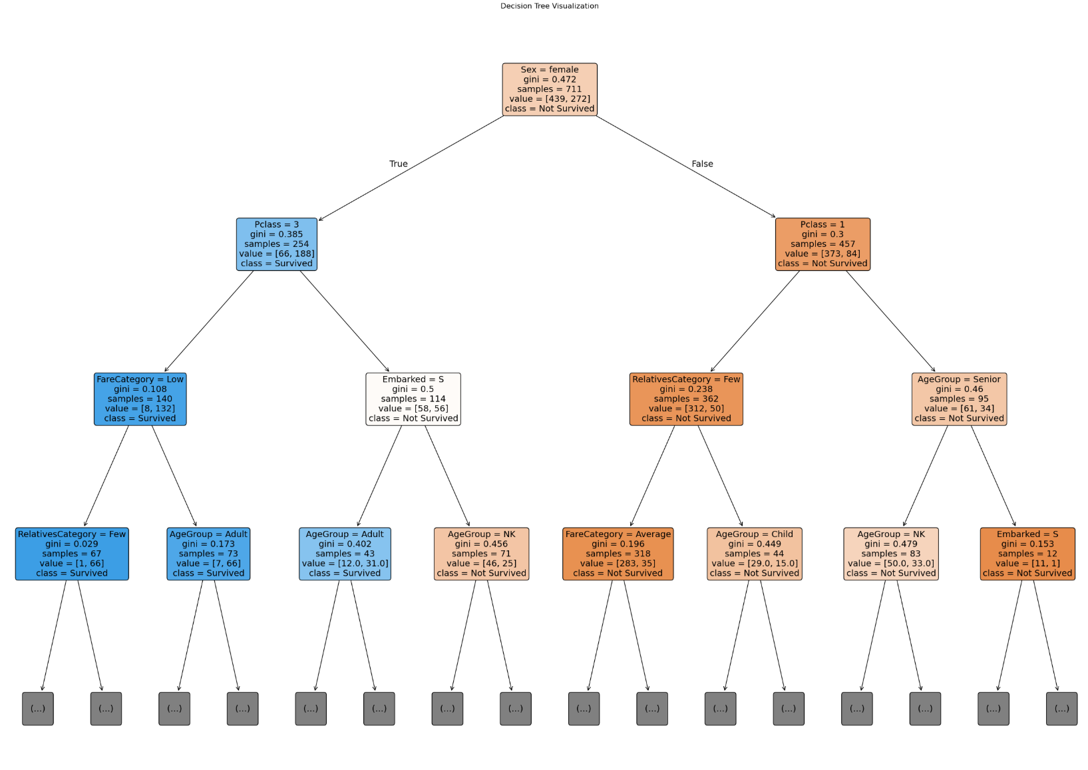
- 5 rules
Five IF-THEN rules are extracted from the tree and printed in human-readable form.
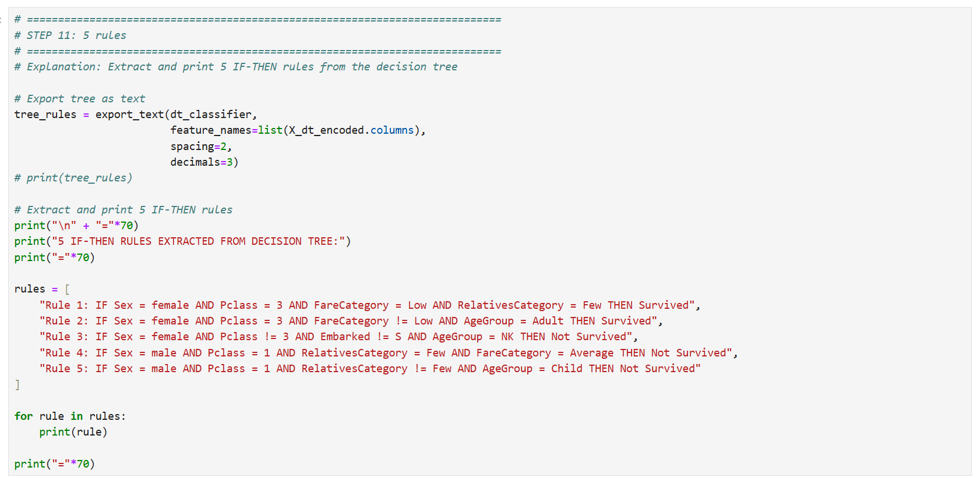
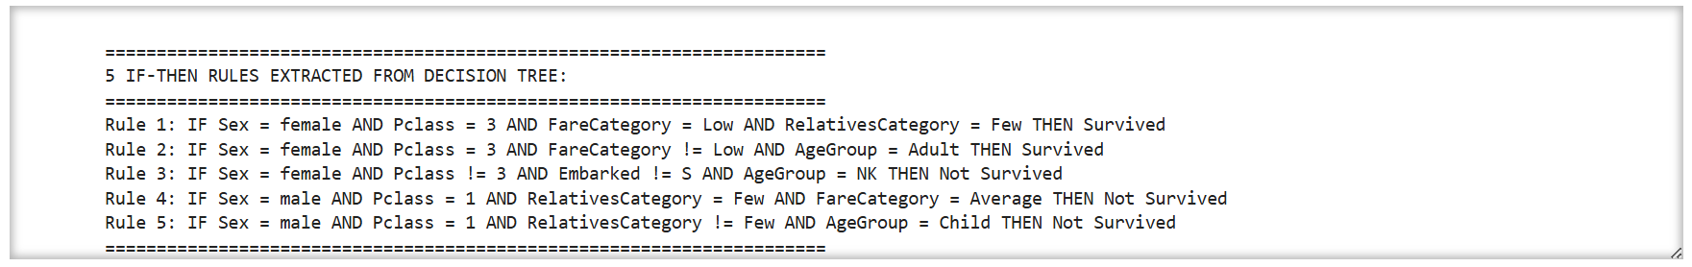
- Data prep for distance-based approach
Data are prepared for KNN: SibSp and Parch are summed into Relatives, and the dataset is split into train and test sets.
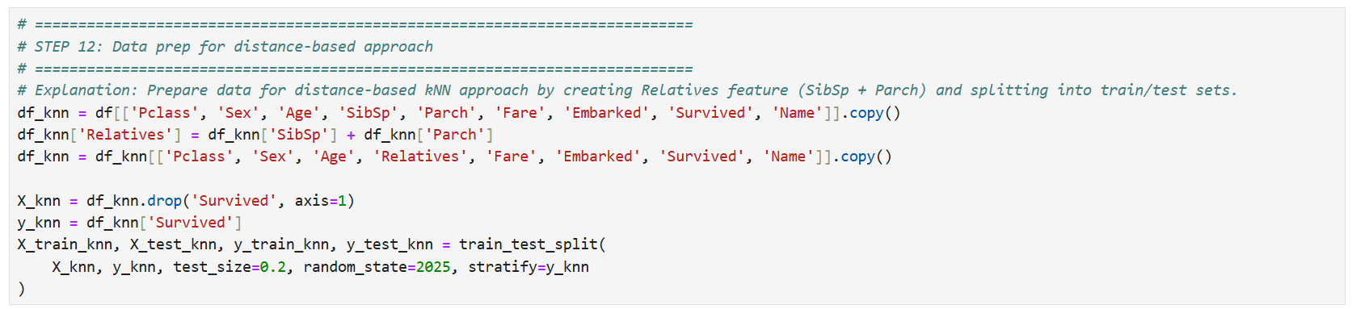
- Handle missing age
Titles are extracted from Name. Average age per title is computed from the training set only. Missing Age values are filled using these averages, then Name and Title are dropped.
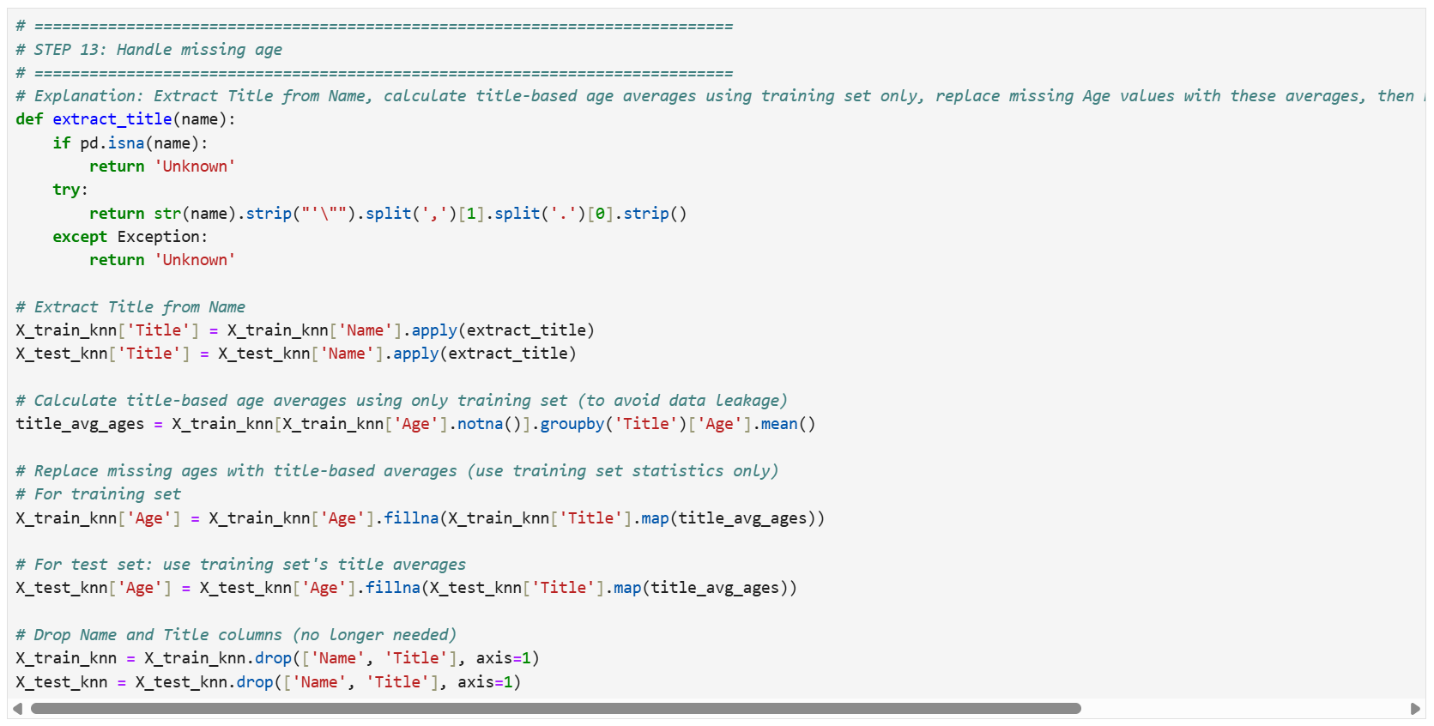
- Scaling
Numerical features(Age, Relatives, Fare) are standardized (mean 0, std 1) to normalize scales for distance calculations in KNN.
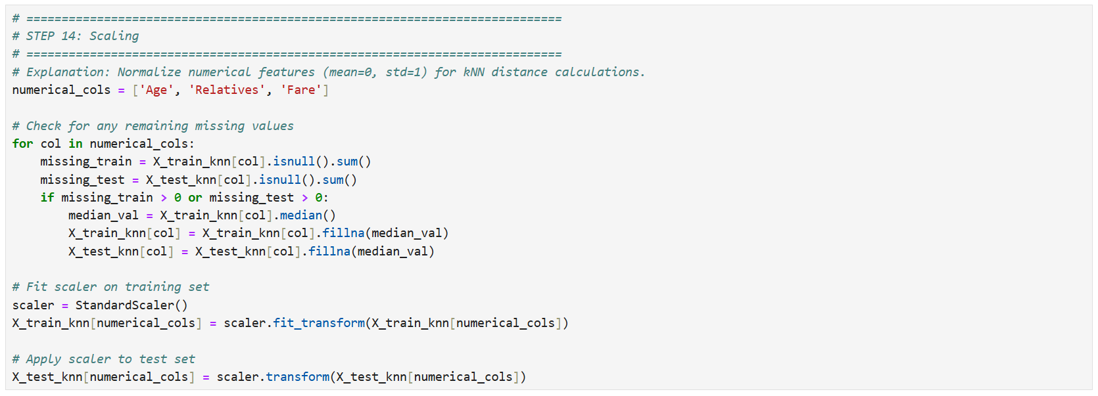
- One-hot encoding
Categories are one-hot encoded. Categorical missing values are filled with the mode. Train and test sets are aligned to ensure identical feature columns.
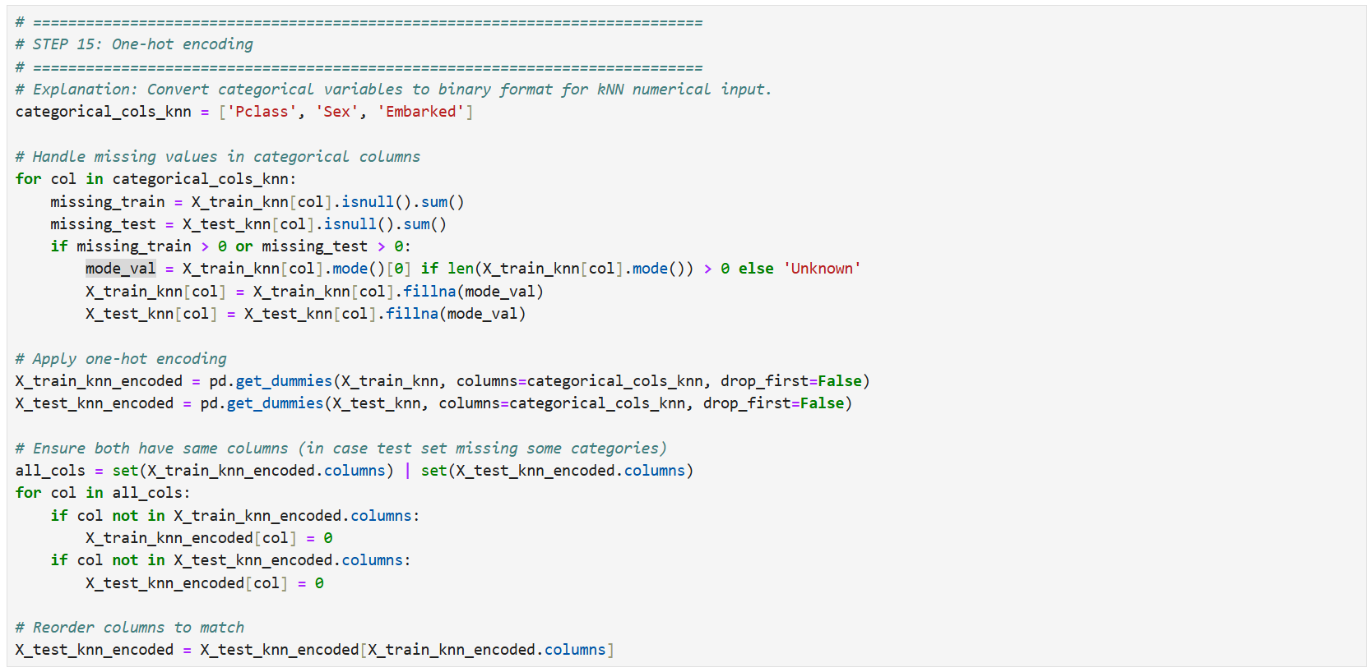
- kNN fit & predict
A KNeighborsClassifier(k=5) is trained. Each test instance is classified by majority vote of its five nearest neighbors. Accuracy and a confusion matrix are computed.
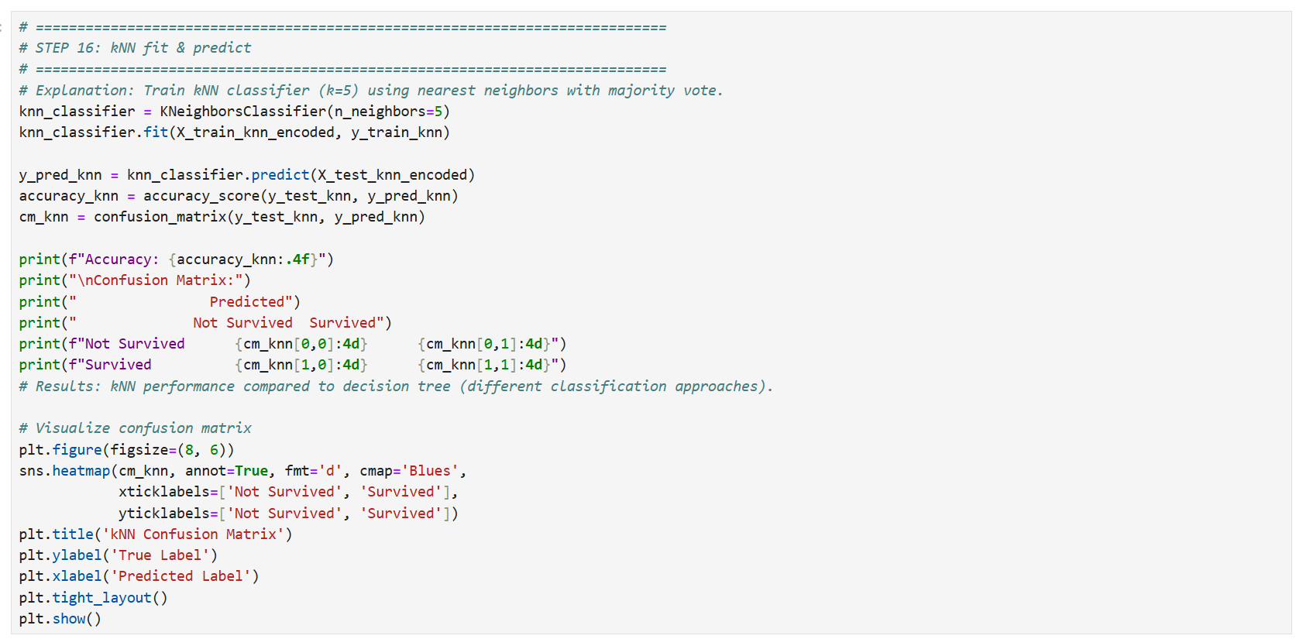
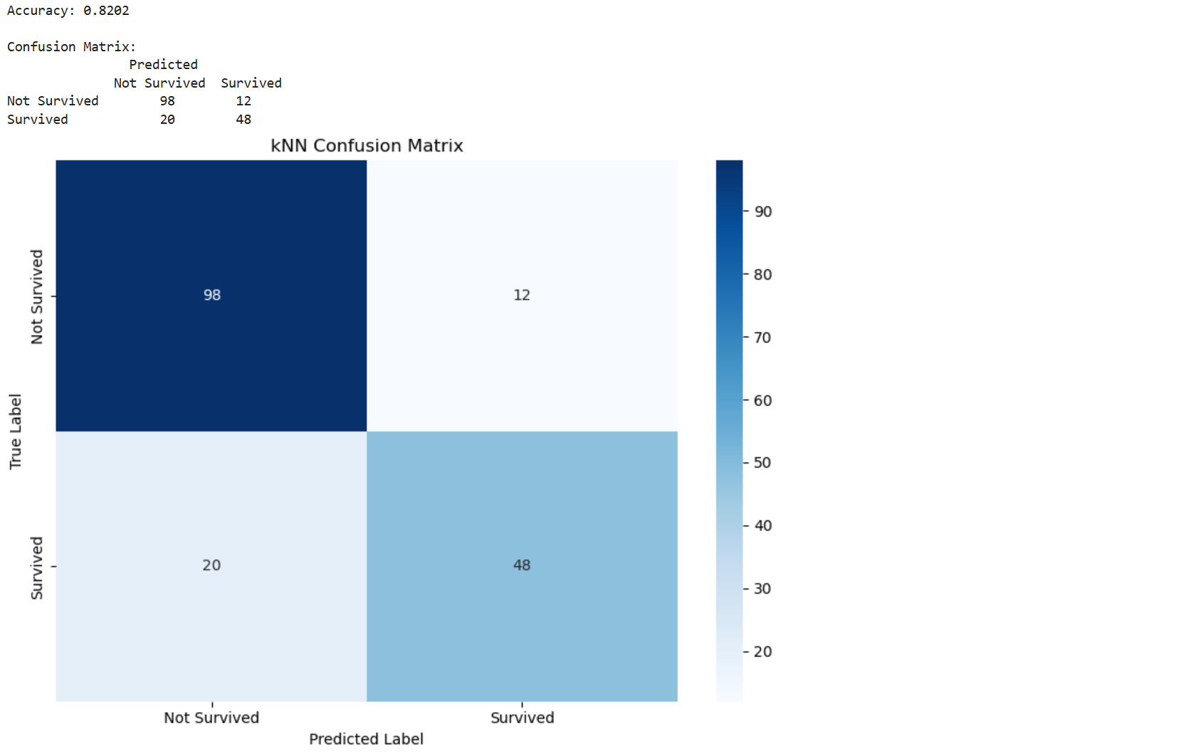
- Bonus
RandomForestClassifier aggregates the predictions of multiple trees by voting.
